Guidelines
DO NOT WRITE HERE, WRITE IN THE SUB TABS!

2. Design Rationale Report (3-5 pages, Team Submission)
Submit a report that explains the "why" behind your design. This document justifies your team's choices and connects them directly to project goals and user needs. It must include:
- Evolution from Low-Fidelity: Discuss how the design has matured. Explain specific improvements made to the layout, user flow, and overall user experience.
- Design System Justification: Explain the rationale behind your color scheme, typography, and overall aesthetic. How does it support the brand identity and improve usability?
- User-Centered Validation: Detail how your final design addresses the user requirements and personas identified in previous phases. Crucially, describe how you incorporated user feedback to refine your design.
- Key Feature Walkthrough: Select one core feature of your application and walk through its design, explaining how the UI/UX choices create an efficient and enjoyable experience for the user.

Evolution from Low-Fidelity
- Discuss how the design has matured. Explain specific improvements made to the layout, user flow, and overall user experience. (0.75 pages)

- Things to maybe write about:
  - More info about users on their profile (Post count, Events hosted, Events Attended)
  - More info visible on the list feed (Replies, People attending, Bookmarks)
  - Days before deletion on Threads/Discussions

Evolution from Low-Fidelity (0.75 pages):
Our design has gone through many significant changes from its original low fidelity design. The main pages, such as the map, pins, and chat, have all gone through major revisions to look like how we want it to. Some of the other pages on the other hand, didn’t need as much revision, like the settings page. We’ve also settled on a color palette to use throughout our entire Figma design too.
The layout of our high fidelity design was made by finding what we needed to change from the low fidelity design to be more easily understood and visually appealing. A notable example of this was our Event Details function. Originally, it looked very cluttered and had no level of aesthetic appeal to it. But, after making the changes we needed, it is now very clear to the user where everything is, what everything means, and looks visually appealing.
As for our user flow, a few changes were made from our low fidelity design. The headers in our pages got adjusted to be more consistent and to match the layout for our user flow. There have also been small changes to some of our pages for quality of life, such as the Profile and Text / List Feed pages. But, besides these minor corrections and adjustments, the core of our user flow has remained the same.
Lastly, our user experience has improved with our high fidelity design. As mentioned before with our design layout and user flow changes, our design is now easier to use and more visually appealing. These changes to all of our pages along with the addition of a color palette creates a more enjoyable user experience for everyone.

Design System Justification
- Explain the rationale behind your color scheme, typography, and overall aesthetic. How does it support the brand identity and improve usability? (0.75 pages)

- Things to maybe write about:
  - Font
    - Easy to read
    - Modern and clean, but approachable due to roundness
  - Color Scheme
    - Using playful colors that encourage playful engagement (purple and cyan esp.) and approachability (easy on the eyes)

Design System Justification (0.75 pages):
After reviewing the color schemes of other popular social media apps, such as TikTok and Instagram, we decided to opt for a color palette that is both vivid and inviting to users, while also creating a cozy environment. Our main color palette consists of purple, pink, and cyan, which have been widely used in other popular apps. Both purple identifies events, but also envelopes most of the website. This gives the UI a uniform look and provides consistency across screens. Meanwhile, cyan is used to identify discussions, and pink is used as an accent color for buttons or other icons. Other shades of these colors are used throughout the website to create more visual depth. Additionally, we chose this color scheme for its approachability. As mentioned before, these colors have been used in other apps, so they’ll provide a sense of familiarity to users and help build a non-corporate feeling through the different shades that are used. Furthermore, we decided to go with the font “Urbanist” for its clean, modern look and roundness, which makes it seem more bubbly and approachable to users.
As for the general layout and aesthetic, we wanted to provide the user with a UI that is easily distinguishable through the color scheme, not cluttered, and easy to understand/learn. We adopted general layouts from other popular apps like Instagram for easy learnability and kept containers separate from each other to provide a clean, organized look. This will evoke a more comfortable experience for the user and promote activity within the website. We also used different icons for discussions and events, keeping in mind users who may be color blind or may need help distinguishing the two. All in all, we want the Bulletin to provide the user with a vivid, organized, and familiar UI that motivates them to stay on the website and interact with others, all while having fun.

User-Centered Validation
- Detail how your final design addresses the user requirements and personas identified in previous phases. Crucially, describe how you incorporated user feedback to refine your design. (1 pages)

- Things to maybe write about:
  - Personas:
    - Using playful colors that encourage playful engagement (purple and cyan esp.) and approachability (easy on the eyes), something our personas may enjoy
  - Interviews
    - Reporting users

User-Centered Validation (1 pages):
Personas based improvements (0.5 pages):
Our final design relied on user-centered validation to help inform decision. The Bulletin’s primary purpose is to allow users to find local events and discussion. To meet these goals, we designed our primary pages around personas that were informed by interviews. Some requirements we gleamed from personas was the need to chat with other users locally, to view events and discussions locally, and a central location to view bookmarks. With that in mind, we wanted to focus our design on the addressing the needs of our personas.
We wanted to address the usability of our app of people who would most likely be using it. We used Liora Calm’s persona to help guide our general flow and design principles. Liora is a more casual user, someone who represents who could be using our app. With that in mind, we wanted our design philosophy to be easy to understand, and highly inclusive to anyone of any technical ability. Large icons displaying where the user is at any time allows the user to see where they are with little confusion. The colors we chose aligned with the relaxing vibe we wanted to bring to users. By using split complementary colors like purple and cyan, we provide contrast without extreme visual tension.
Interviews (.5 pages):
What many of our interviewees prioritized when using a social media app, was ease of use and navigability. After all, users wouldn’t want to use an app if it’s clunky, confusing, and crammed with info. We catered around this by designing the visual elements, such as the navigation bar, to be large and in a distinct color in order to make them stand out and easy for the user to tap on. Furthermore, we incorporated familiar design elements so that users who are familiar with their iconography can immediately figure out their purpose without causing needless confusion. Instances of these implementations include the “hamburger menu” that contains the settings and profile pages, as well as the back arrow to allow the users to exit these submenus. The hamburger menu also helps us to avoid the issue of having too many icons cluttering the bottom UI navigation with additional tabs, which would make it harder to use. We also gave the updates tab a dedicated icon on the home page, so that users can quickly and easily check any notifications upon entering The Bulletin. By focusing on being convenient and straightforward to use, The Bulletin will become easy for new users to adopt and use on a daily basis.

REFERENCE: Personas
A REFERENCE, DO NOT WRITE HERE

Developed Personas:
Persona 1: Liora Calm : The introverted listener:

Many of us find value in listening, and Liora has learned a lot from listening first before doing. At 31 years of age, they are a loving parent of 3 who finds value in patience and thinking things through before acting. When she’s not at work or taking care of her children, she spends her time at home, catching up on her hobby: reading. On her days off, while her husband is at work, and her children are away at school, Liora finds herself with lots of free time.
Although she’s perfectly content with reading alone, she feels lonely without someone to confide in about her reading – someone to discuss plot points or certain scenes about. What she needs is a book club, one preferably close by. Although she likely won’t add much to the conversation, she’d prefer to just listen to whatever discourse they have on whatever books they’re reading. It can also serve as a way for Liora to get recommendations on what titles she can read next.

Persona 2: David Jones : The event planner:
David is a seasoned event planner who strives to bring joy to his clients and ensure they have the time of their lives at their events. He works hard to make sure that all party services are scheduled correctly and that the client’s needs are met. As a grandfather to 3 young grandchildren, David wants to plan community events so that his grandchildren, and many others, can enjoy their time together and have fun. Throughout his career he has stuck to pen-and-paper and is not familiar with technology since his children usually help him with tech heavy tasks.
Although David is confident in his planning skills, he is not sure how he will reach out to others in the community since most of his events are in a controlled (invite-only) environment. Platforms like Twitter and Reddit are a no-go, as David doesn’t have much of a personal following so no one would see his posts. The only social media platform he is familiar with is Facebook, but he mostly uses it to keep in touch with friends and family and wouldn’t know where to begin if he wanted to advertise an event on there. Furthermore, the only people he would be able to invite are his Facebook friends, mostly his colleagues and acquaintances all similar in age to him; not exactly the most ideal crowd for community-wide events.

Persona 3: Solana Knowles : The new, friendly University student:
When starting University, many of us find ourselves in a completely new environment with no connections. Solana, a new student, is entering the second week of her first semester and she has yet to make any acquaintances. In high school, she was very outgoing and felt comfortable with her friends. Now she attends class and asks her classmates for help when needed, but she feels as though their conversations are very surface level and she can’t quite get close to anyone.
One day, she overhears her classmates talking about the music club, and she gets inspired to join a club. Seeing as she’s a frequent online user, she starts to look for different clubs on instagram and eventually finds the movie club’s online chat. They have an event that will take place that same day and while Solana is excited to join the club, she is also nervous because she doesn’t know anyone from the club. Considering she has only seen people chat online, she doesn't know who they may be behind the screen or if they have good intentions.

Persona 4: Jordan “Jay” Martinez : The extroverted, loose cannon:

Extroverts are not the type to revel in cabin fever. Jay is no exception to this, he’s a 28 year old engineering major who absolutely loves getting out on the weekend. World is tough, and living in his own studio apartment has given him a lot of freedom - yet when you live alone and don’t know a lot of folk, it makes Jay even more eccentric - and everything becomes a new adventure for him.
However, that sentiment is not always shared. Time and time again he’s tried to plan events through messaging online friends, only to find they’re not interested in going out. Finding others who share both his interest and out-going energy is extremely difficult. The time and energy spent searching and searching for online communities isn’t helping either. You have to already know people to get invited to the Telegram chats for niche hobbies. He would have never guessed there’s a private Dance Dance Revolution group on telegram that plans out excursions to the Round 1 Arcade for round robin dancing. He has to rely mostly on Telegram since the nature of the application allows for more personalized discussion with others without the overhead of his identity being exposed. He feels more at ease expressing his true self in this environment, and loves sending personal photos of his excursions without telling the whole world about it. He prefers to keep it local. Trying to go to the arcade with someone on the other side of the world is a tad difficult, and there’s something meaningful when they’re right in front of you. For Jay, face-to-face conversation will never go out of style, and finds the hassle of endlessly messaging people on popular platforms to be quite the chore. Jay has also grown exhausted of having to constantly deal with miscommunication issues in online discussions, since his more eccentric nature can result in people misreading his sarcasm as hostility: an issue he doesn’t have when socializing in-person. He’s a simple person - he wants to let everyone know he’s going somewhere and if they wanna tag along, and that’s it. Instead of chasing others, keeping accountability, he just wants to socialize with others. In fact, the thrill of meeting new people who willingly travel to hang out and enjoy similar interests with Jay is what motivates him to keep going.

REFERENCE: Interviews
A REFERENCE, DO NOT WRITE HERE

Interview Key Insights Graphs:
- Reliance On Word of Mouth and/or Pure Luck:
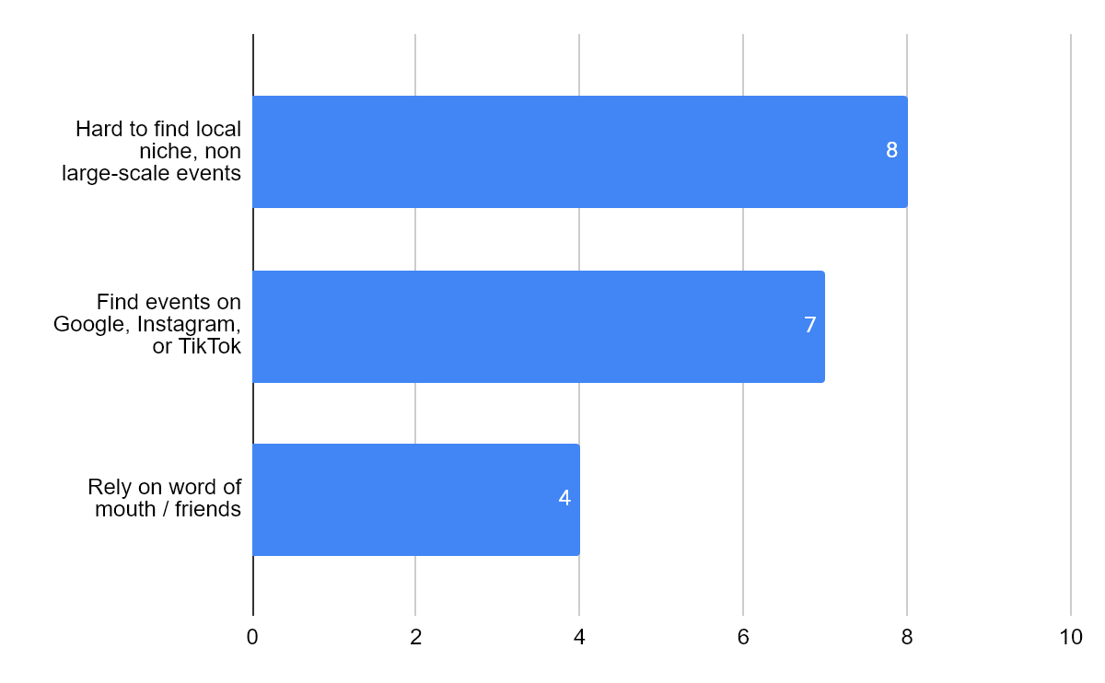
- Fragmented Communities and Oversaturation:
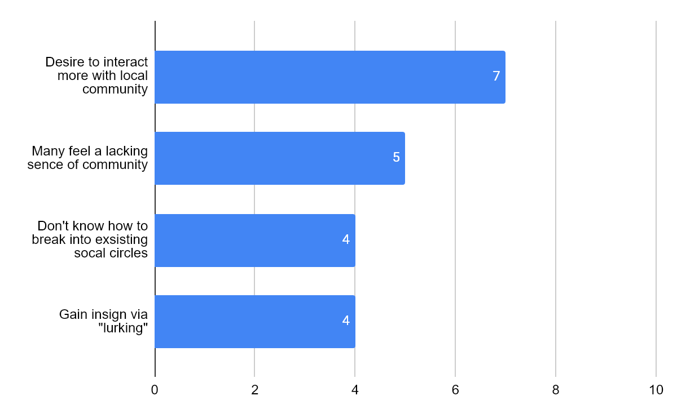
- Constrained and/or Frustrated by the Tools of Existing Platforms:
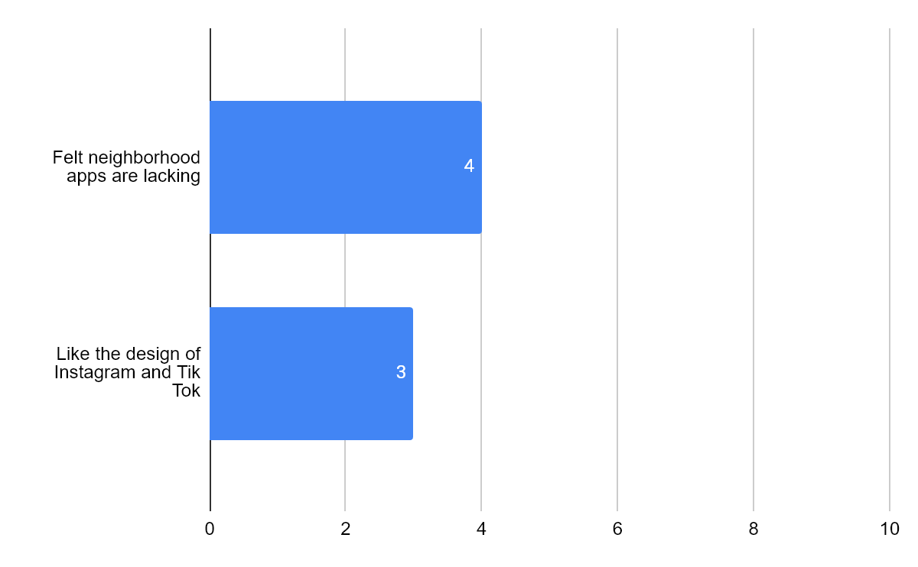
- Security and Privacy Concerns:
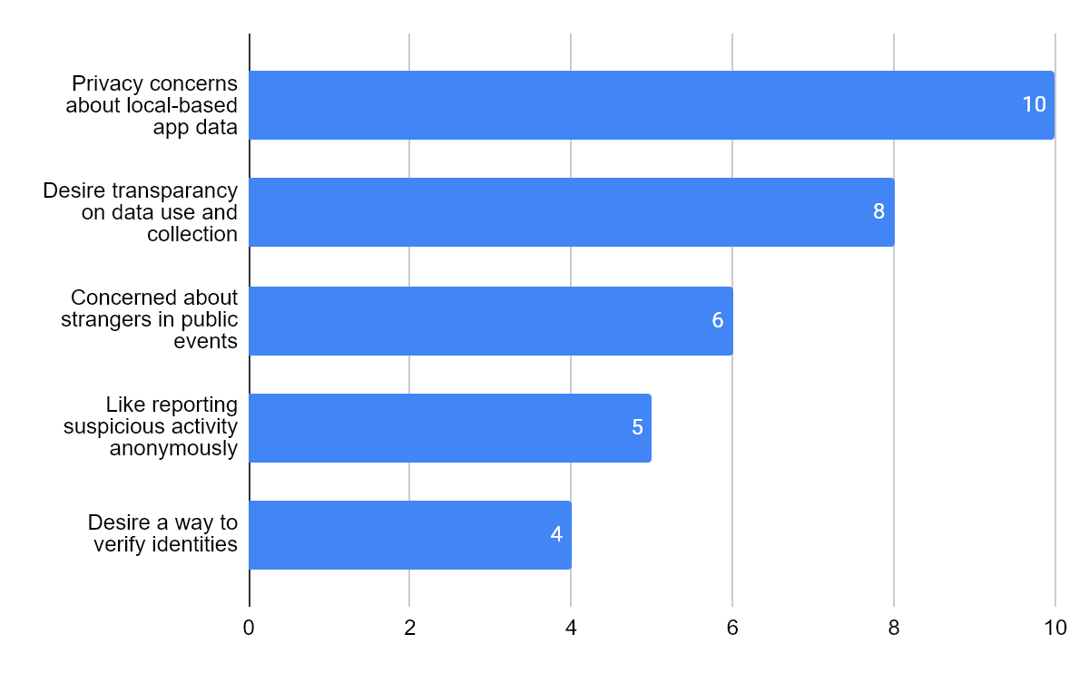
- Preference for Intuitive Elements and Visuals:
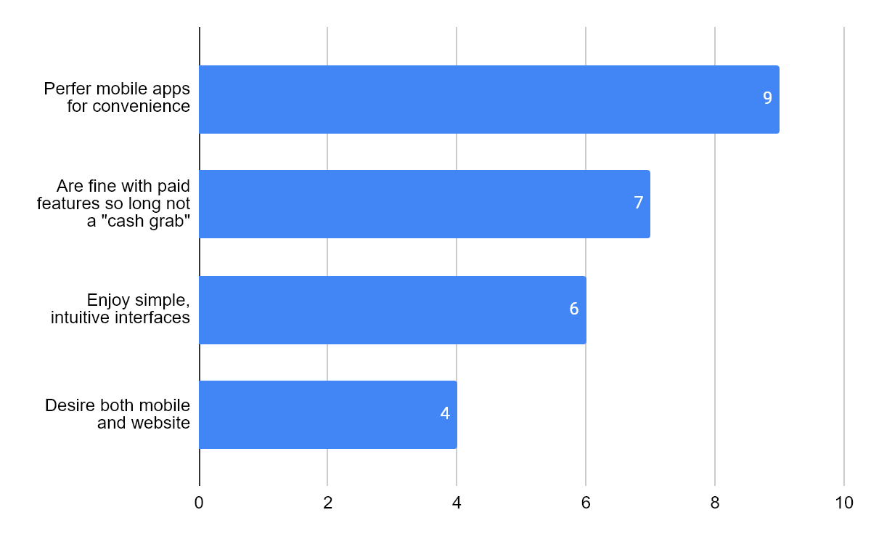

Interview Key Insights Details:
Key Insight: Reliance On Word of Mouth and/or Pure Luck:
Interviewee’s explicitly mention having to rely on friends or even their own family members (spouses) to inform them of local events. While others may happily browse and explore the internet to find what’s happening locally, they feel they waste too much time and energy. At times, they felt frustrated since their searches can feel futile, especially given if they’re not even sure if they’re searching in the right place to begin with. Should they push through and continue searching, they are only punished by the algorithm. The irony in continuing their search is that they have now left behind a search history - ripe for data collection. Intentionally ignoring the security concern here to address another issue: advertisements and content generated based on their actions. A quick zoom out of the situation shows the larger picture: a feedback loop. Should a user ‘miss’ the target, they can continue to miss exponentially as content is shifted and mis-clicks can lead to redirection for the sake of websites trying to show sponsored content or even their biases. Now combine this with the issue of living in a large city: every single major corporation is fighting for your attention, to get you to go to their events. How exactly are you going to find what’s going on locally when you see the Staple Center is advertising their crypto arena convention this upcoming weekend? Many, for the sake of their sanity, have chosen the stance "the best move is not to play.”

Key Insight: Fragmented Communities and Oversaturation:

Users who lean more towards the extroverted nature find existing applications to fall short of what they desire. A common issue is “where do I go to tell others?” While users might be in existing Telegram group chats or Discord, there isn’t a singular location they go. This is governed by an uncontrollable variable - which is that everyone has their own preference, and they don’t want to budge. You can run into situations where a user has to copy-paste event planning discussions to multiple platforms to catch others up to speed or run the risk that some people will get left behind since they didn’t check the application they’re using to plan the event. A sort of “can someone tell [x] were planning an event?” Having to get everyone on the same page before the event is even finalized is a challenge in itself. A lot of times users want to skip that entirely - give them the event time and place, and they decide if they go or not.
Decision fatigue is a common theme distilled from the team’s interviews. One might not have guessed that asking the simple question “how do you keep ALL your friends up to date?” leads to the exhausting response of “I can’t.” Disregarding the individual philosophies of the interviewees in regards to their preference over a centralized or decentralized social network - the fact is, a lot of the tools created by other platforms allow for users to completely disregard any communication outside of that. A commonly used term for this situation is known as an “echo chamber.” While being able to privately communicate with friends is an amazing feature, there seems to be a shift where over time, users on a social media platform will begin to form private groups - communicating only with those they know directly. This is not a feature that should be taken away. In fact, the reason why a lot of users choose this route is because of how volatile the internet can be: a minefield, to put it lightly. Fighting the algorithm is a behemoth of a task already, but there’s still more.

Key Insight: Constrained and/or Frustrated by the Tools of Existing Platforms:
The individuals selected for interviews aren’t using pre-existing applications for local communication such as NextDoor. Many expressed frustration in that fact “nothing happens” when using such apps and that many people only use these apps only to complain and gossip. These users are seeking a way to actually create activities and get people together for events - not just text all day. There seems to be two common extremes: the first being users forced to engage with the platform, which can result in undesired consequences such as online hostility and users feeling unsafe to even initiate conversation. The second extreme is an application where users are so disengaged that the platform is dead on arrival. This can result in an application being so disconnected from reality that the user feels as if they’re wasting their time and begin their search for greener pastures.
It’s no secret then that social media apps focus heavily on having their users engage with their application. Notice how ‘engage’ by itself doesn’t actually mean anything when isolated - it’s just a verb. What this means is that the content the users engage with is irrelevant. For the major companies, this means limiting users to intentionally digging through endless material to find local events. During the interviews, people were asked about a particular feature - location based filtering. This one got a few eyebrow raises. The concept of being able to search for events based on distance meant they could find what they were looking for, and move on. This meant even smaller events could gain a spotlight, and that popularity alone was no longer a contest. Yet what we are left with are frustrated users who don’t have such a tool, because it goes against the focus and motivations of existing platforms.

Key Insight: Security and Privacy Concerns:
Nearly all interviewed were very much worried about how location is used in current applications, mentioning concerns with privacy on how their locations and interactions will be tracked or sold. The interviewees understand that locational data is necessary for certain applications to function, such as in Yelp or Google Maps, but value transparency on how such data is used. The preciseness of the tracking was one of many people's interests. Eight of the interviews were in strong support of more general locations being used, feeling that if precise locational data isn’t necessary for the task then it should not be used.
Upon the topic of safety, one of our key interests is making nearby public events more visible. People liked the idea of being able to quickly find events; but those interviewed, particularly women, expressed valid concerns about going to public events and how to gauge the safety of these posted events. They stated that they understand that anyone can post anything onto any social media website, even malicious actors, so ways to gauge safety would be greatly appreciated. Some methods include ways to gauge interest, the number of people attending via “likes”, the location of the event to see how publicly visible it is, and ways to verify if the event is legit.
Interviewees also discussed the safety of less tech savvy users and the content of these locational based forums. Those that mentioned it emphasized the need for transparency with user data and the use of warnings before any post is finalized, especially considering how one could accidentally send sensitive positional data. Those interviewed referenced the ability to report user generated content and a not-too restrictive filter on every post to prevent any obviously nefarious content seen on other social media platforms.

Key Insight: Preference for Intuitive Elements and Visuals:
Images can speak a thousand words. While using sliders to filter events based on distance is something that has genuinely piqued the interest of our interviewees, any mention of a map or some visual cue was met with an immediate approval. Being able to see on a map that a hypothetical get-together is happening “Just east, a mile down,” from someone's current location would relieve much of the confusion in understanding directions and proximity. There would be no need of having to follow vague directions to a location you’ve never been to, like “Oh yeah, it’s down the street next to the Starbucks,” when there’s a dozen Starbucks on that street alone.
Given our culture in using platforms that incorporate location based visual aids such as Google Maps or Pokemon GO, people felt that implementing a similar feature would come intuitively and cause a lot less headache. One of the goals of our project is to streamline the hiccups that occur during event planning, namely deciding on a place to hang out. Being able to see real-time current events on a map is worth pivoting towards as we create the foundation for such a feature.
To further expand on this, interviewees made some interesting suggestions: being able to filter based on the event type, being able to click and see specific details, and even a number counter showing how many people are attending. Regarding safety, users knowing that an event they will be attending would include a large number of people would lower personal risk since safety in numbers.

Key Feature Walkthrough
- Select one core feature of your application and walk through its design, explaining how the UI/UX choices create an efficient and enjoyable experience for the user. (0.75 pages)

(Troy Waters)

Key Feature (Event/Thread Creation) Walkthrough:
The focus for this walkthrough will be the main feature of this application: the creation of events and threads from the home page. After a user clicks the plus icon on either the map or list page, they are carried to a new page where they have the immediate choice to swap between creating a new discussion or an event. Instead of forcing users to immediately decide what they’re creating, we instead shifted towards a design that gives users the choice to swap at will. During initial design they were two separate pages, but during the creation of the logic it was apparent they shared many similar attributes: title, description, a date, etc. What this means is if a thread or an event share a similar feature, it's immediately carried over to its counterpart. A user decides to type in a title for example: “Anyone up for a BBQ at the Park?” However, that user doesn’t realize they’re creating a thread, not an event. With a single tap they swap into Event creation mode where that same title they typed will carry over. It would be awfully inconvenient for a user to forceable retype such details - this becomes especially true if they typed a whole paragraph and it was erased. A small but important detail is actually how the text boxes for user input already contain information - questions, in fact: “Throwing a birthday party? Or perhaps an arcade hangout?” While it seems trivial at first, this in fact helps guide users towards communicating more effectively. This doubles down as well as someone to ease the user into filling quite a selection of options: would it be easier to be greeted by ten empty text fields or ten with some text already in them so as to not overwhelm the user? For both creation types there is a visual option: for discussions, a user can upload a photo to compliment the discussion. For events, it navigates to the map so that the user can pin the location for the upcoming event. And right before the user can post their event, a date and time is selected. This brings up a calendar overlay to facilitate the tap of a finger for choosing the date and time of their choice. Once either a discussion or event is posted, the user is carried to a more detailed overview of their creation. For first time users, this is a way of showing them there’s a way to expand the details of pins they see on a map so they may find out more information. For events, a participant counter shows the amount of people who chose to attend the upcoming meeting. Both feature a scrollable chat function, which serve any purpose the user may see fit: telling others they’re going, any questions they might have, or just to leave a fun comment. It should be noted that at any time during this process the user has access to the “return to previous page” button. Whether a user changes their mind or accidentally chooses to create an event, our design follows the belief in never letting a user feel stuck to ensure they’re never frustrated. A final comment that should be noted is that the discussion creation page also includes a map similar to the event creation page, but isn’t meant to interact with. To ensure user safety we felt it was paramount to remind them that while they may create a discussion pin in their local area, it will never be pinned in their exact location but instead an approximate nearby area. This version of the map serves as a constant visual reminder of our concern for their safety.

Final Report
Group 6: Team Pinpoint
Andy Hoang, Citlally Vasquez, Darrel Dennis, Max Ju, Troy Waters, Wai Soltow
Design Rationale Report
Evolution from Low-Fidelity:
Our design has gone through many significant changes from its original low fidelity design. The main pages, such as the map, pins, and chat, have all gone through major revisions to look like how we want it to. Some of the other pages on the other hand, didn’t need as much revision, like the settings page. We’ve also settled on a color palette to use throughout our entire Figma design too.
The layout of our high fidelity design was made by finding what we needed to change from the low fidelity design to be more easily understood and visually appealing. A notable example of this was our Event Details function. Originally, it looked very cluttered and had no level of aesthetic appeal to it. But, after making the changes we needed, it is now very clear to the user where everything is, what everything means, and looks visually appealing.
As for our user flow, a few changes were made from our low fidelity design. The headers in our pages got adjusted to be more consistent and to match the layout for our user flow. There have also been small changes to some of our pages for quality of life, such as the Profile and Text / List Feed pages. But, besides these minor corrections and adjustments, the core of our user flow has remained the same.
Lastly, our user experience has improved with our high fidelity design. As mentioned before with our design layout and user flow changes, our design is now easier to use and more visually appealing. These changes to all of our pages along with the addition of a color palette creates a more enjoyable user experience for everyone.
Design System Justification:
After reviewing the color schemes of other popular social media apps, such as TikTok and Instagram, we decided to opt for a color palette that is both vivid and inviting to users, while also creating a cozy environment. Our main color palette consists of purple, pink, and cyan, which have been widely used in other popular apps. Both purple identifies events, but also envelopes most of the website. This gives the UI a uniform look and provides consistency across screens. Meanwhile, cyan is used to identify discussions, and pink is used as an accent color for buttons or other icons. Other shades of these colors are used throughout the website to create more visual depth. Additionally, we chose this color scheme for its approachability. As mentioned before, these colors have been used in other apps, so they’ll provide a sense of familiarity to users and help build a non-corporate feeling through the different shades that are used. Furthermore, we decided to go with the font “Urbanist” for its clean, modern look and roundness, which makes it seem more bubbly and approachable to users.
As for the general layout and aesthetic, we wanted to provide the user with a UI that is easily distinguishable through the color scheme, not cluttered, and easy to understand/learn. We adopted general layouts from other popular apps like Instagram for easy learnability and kept containers separate from each other to provide a clean, organized look. This will evoke a more comfortable experience for the user and promote activity within the website. We also used different icons for discussions and events, keeping in mind users who may be color blind or may need help distinguishing the two. All in all, we want the Bulletin to provide the user with a vivid, organized, and familiar UI that motivates them to stay on the website and interact with others, all while having fun.
User-Centered Validation:
Personas based improvements:
Our final design relied on user-centered validation to help inform decisions. The Bulletin’s primary purpose is to allow users to find local events and discussion. To meet these goals, we designed our primary pages around personas that were informed by interviews. Some requirements we gleaned from personas were the need to chat with other users locally, to view events and discussions locally, and a central location to view bookmarks. With that in mind, we wanted to focus our design on addressing the needs of our personas.
We wanted to address the usability of our app for people who would most likely be using it. We used Liora Calm’s persona to help guide our general flow and design principles. Liora is a more casual user, someone who represents who could be using our app. With that in mind, we wanted our design philosophy to be easy to understand, and highly inclusive to anyone of any technical ability. Large icons displaying where the user is at any time allows the user to see where they are with little confusion. The colors we chose aligned with the relaxing vibe we wanted to bring to users. By using split complementary colors like purple and cyan, we provide contrast without extreme visual tension.
Interviews:
What many of our interviewees prioritized when using a social media app, was ease of use and navigability. After all, users wouldn’t want to use an app if it’s clunky, confusing, and crammed with info. We catered around this by designing the visual elements, such as the navigation bar, to be large and in a distinct color in order to make them stand out and easy for the user to tap on. Furthermore, we incorporated familiar design elements so that users who are familiar with their iconography can immediately figure out their purpose without causing needless confusion. Instances of these implementations include the “hamburger menu” that contains the settings and profile pages, as well as the back arrow to allow the users to exit these submenus. The hamburger menu also helps us to avoid the issue of having too many icons cluttering the bottom UI navigation with additional tabs, which would make it harder to use. We also gave the updates tab a dedicated icon on the home page, so that users can quickly and easily check any notifications upon entering The Bulletin. By focusing on being convenient and straightforward to use, The Bulletin will become easy for new users to adopt and use on a daily basis.
Key Feature (Event/Thread Creation) Walkthrough:
The focus for this walkthrough will be the main feature of this application: the creation of events and threads from the home page. After a user clicks the plus icon on either the map or list page, they are carried to a new page where they have the immediate choice to swap between creating a new discussion or an event. Instead of forcing users to immediately decide what they’re creating, we instead shifted towards a design that gives users the choice to swap at will. During initial design they were two separate pages, but during the creation of the logic it was apparent they shared many similar attributes: title, description, a date, etc. What this means is if a thread or an event share a similar feature, it's immediately carried over to its counterpart. A user decides to type in a title for example: “Anyone up for a BBQ at the Park?” However, that user doesn’t realize they’re creating a thread, not an event. With a single tap they swap into Event creation mode where that same title they typed will carry over. It would be awfully inconvenient for a user to be forced into retyping such details - this becomes especially true if they typed a whole paragraph and it was erased. A small but important detail is actually how the text boxes for user input already contain information - questions, in fact: “Throwing a birthday party? Or perhaps an arcade hangout?” While it seems trivial at first, this in fact helps guide users towards communicating more effectively. This doubles down as well as someone to ease the user into filling quite a selection of options: would it be easier to be greeted by ten empty text fields or ten with some text already in them so as to not overwhelm the user? For both creation types there is a visual option: for discussions, a user can upload a photo to compliment the discussion. For events, it navigates to the map so that the user can pin the location for the upcoming event. And right before the user can post their event, a date and time is selected. This brings up a calendar overlay to facilitate the tap of a finger for choosing the date and time of their choice. Once either a discussion or event is posted, the user is carried to a more detailed overview of their creation. For first time users, this is a way of showing them there’s a way to expand the details of pins they see on a map so they may find out more information. For events, a participant counter shows the amount of people who chose to attend the upcoming meeting. Both feature a scrollable chat function, which serve any purpose the user may see fit: telling others they’re going, any questions they might have, or just to leave a fun comment. It should be noted that at any time during this process the user has access to the “return to previous page” button. Whether a user changes their mind or accidentally chooses to create an event, our design follows the belief in never letting a user feel stuck to ensure they’re never frustrated. A final comment that should be noted is that the discussion creation page also includes a map similar to the event creation page, but isn’t meant to interact with. To ensure user safety we felt it was paramount to remind them that while they may create a discussion pin in their local area, it will never be pinned in their exact location but instead an approximate nearby area. This version of the map serves as a constant visual reminder of our concern for their safety.

